# **Department of Computer Science and Engineering Islamic University of Technology (IUT)** A subsidiary organ of OIC

# **Lab Report 02**

# CSE 4512 : Computer Networks Lab

## 

## **Name: Zawad Bin Shoukat (Tasin) Student ID: 210041257 Section: 2(A) Semester: 5th Academic Year: 2023-24**

**Date of Submission: 23/09/2024**

### **Title:** Configure router using static routing to connect multiple networks in Cisco Packet Tracer

### **Objectives**:

1. Understand how to operate Cisco Packet Tracer
2. Learn to create and connect multiple networks using static routing
3. Understand wiring of different network components like router, switch, PC etc.
4. Configure router and switch interfaces
5. Verify connectivity of the network

### **Diagram of the experiment:**

(Provide screenshot of the final network topology. Make sure to label the network components.)

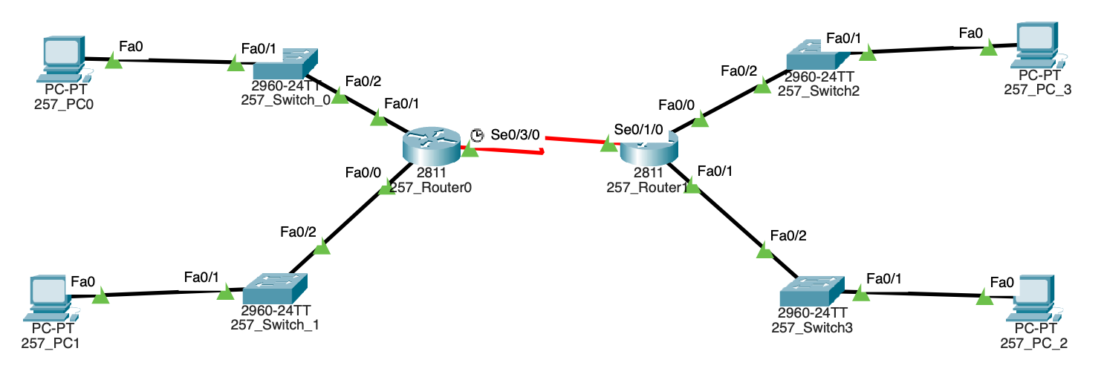

### 

### **Working Procedure:**

**(**Explain in brief how you completed the tasks. Provide necessary screenshots of used commands for each task.)

**Task 01:**

At first I configured both of the routers for the four fastEthernet ports.

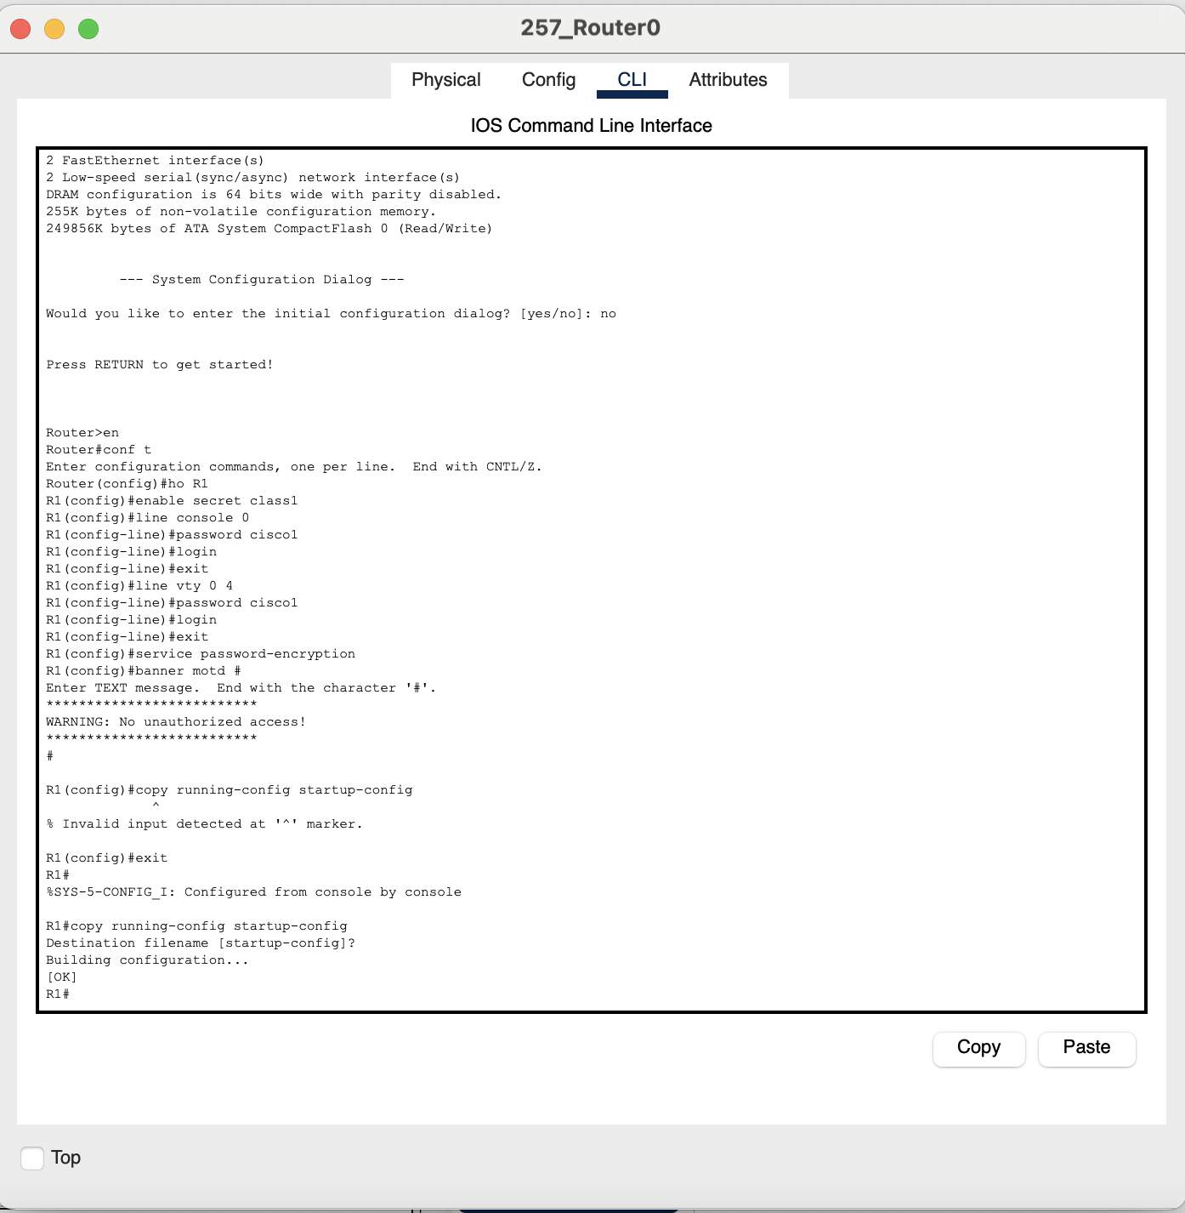

**Task 02:**

Configured the router interfaces with proper ip addressing as given in the network specification.

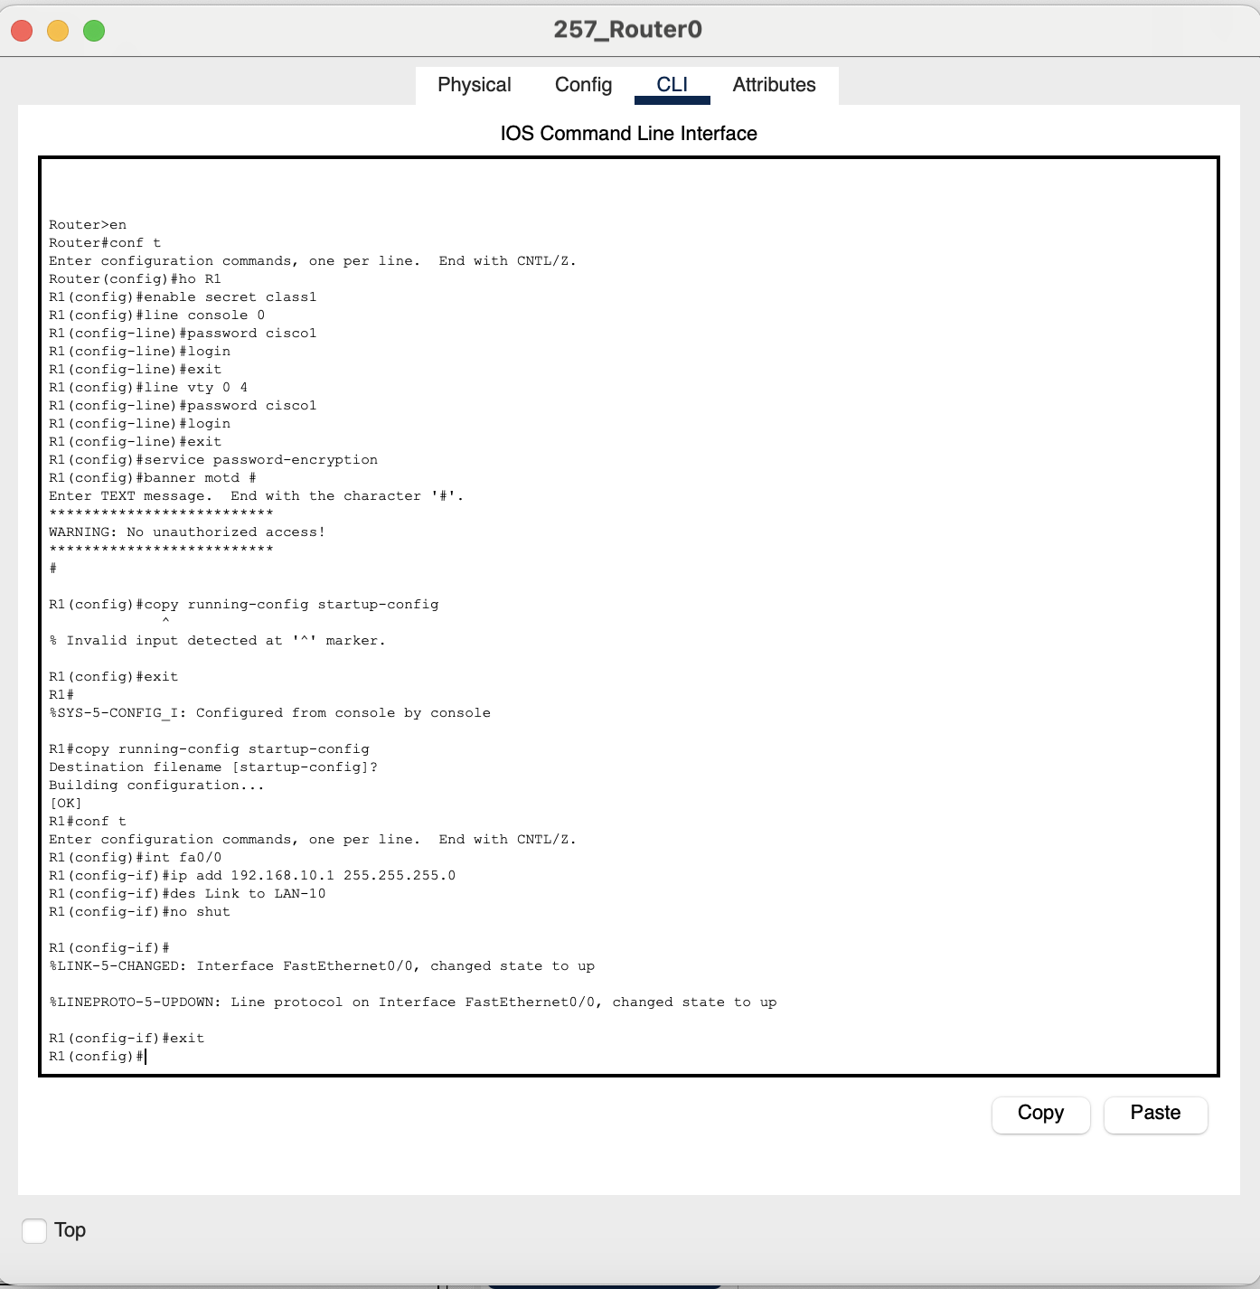

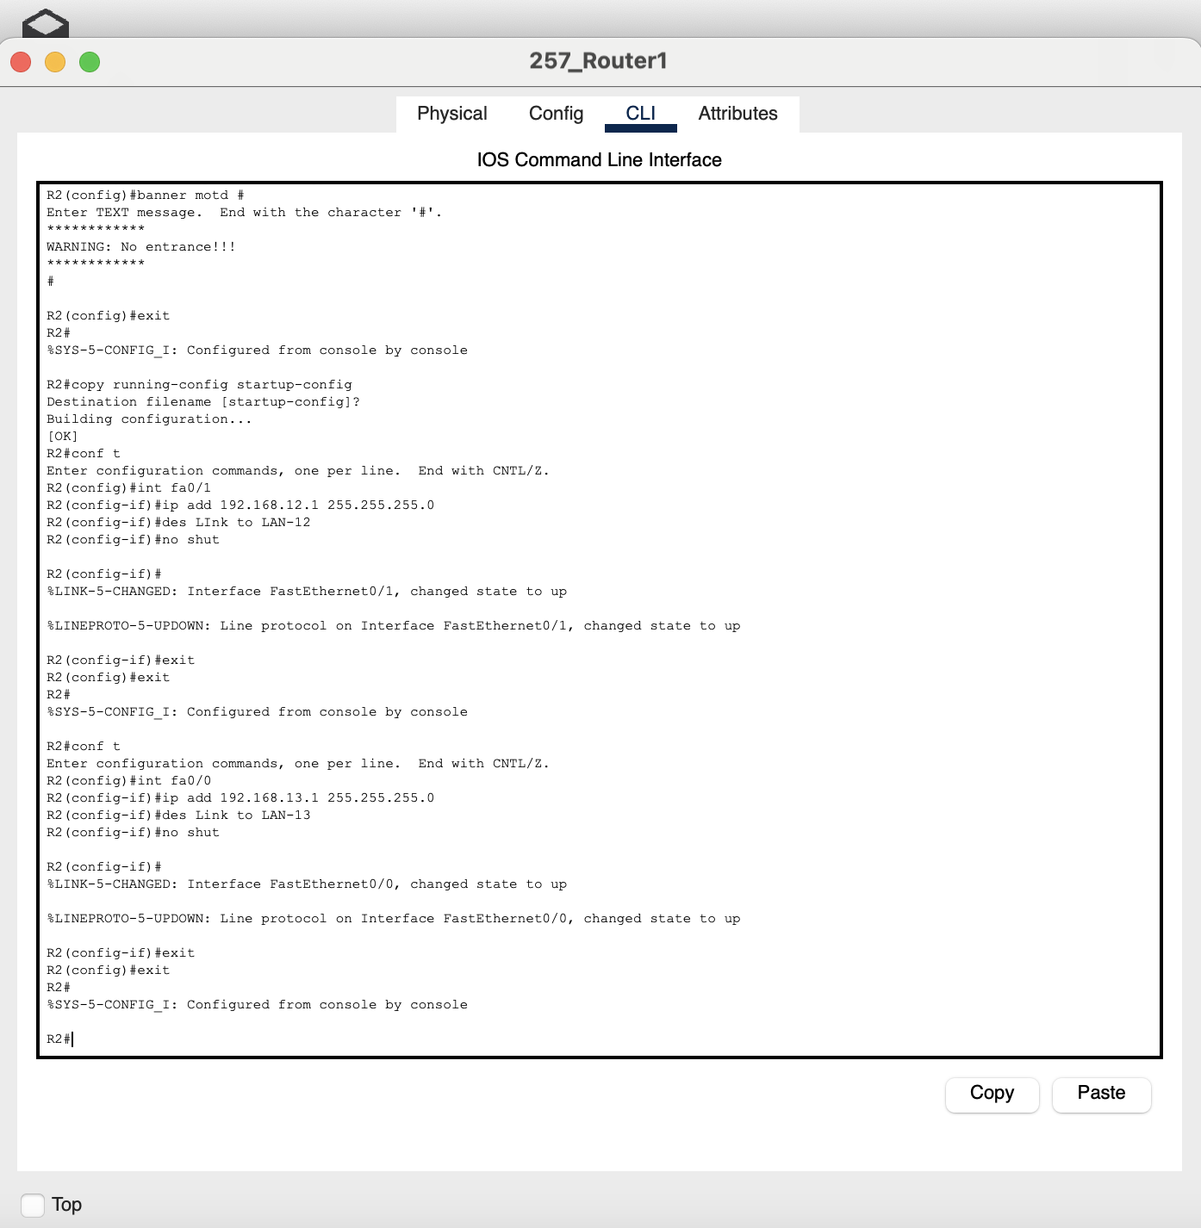

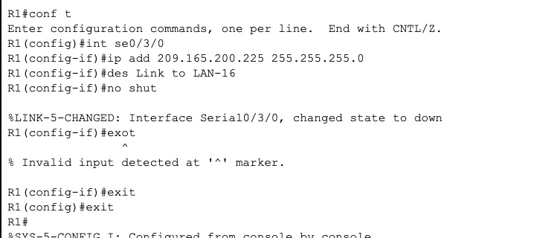

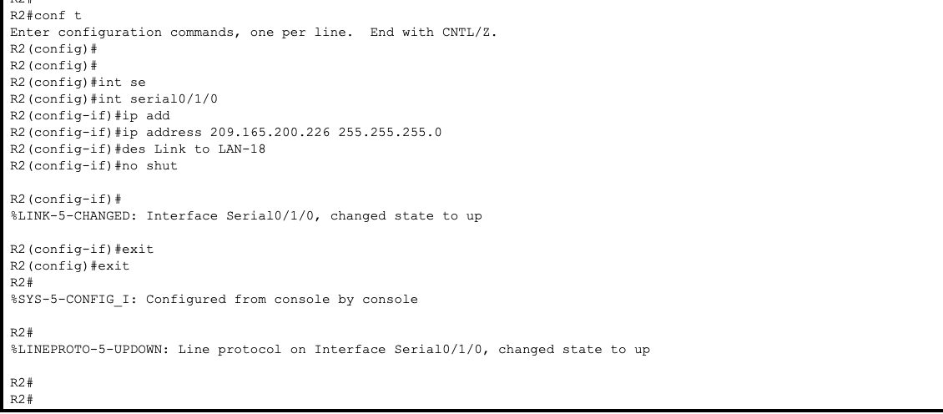

Added the ip addresses for the fastEthernet and Serial ports.

**Task 03:**

Desktop>IP Configuration inside a PC.

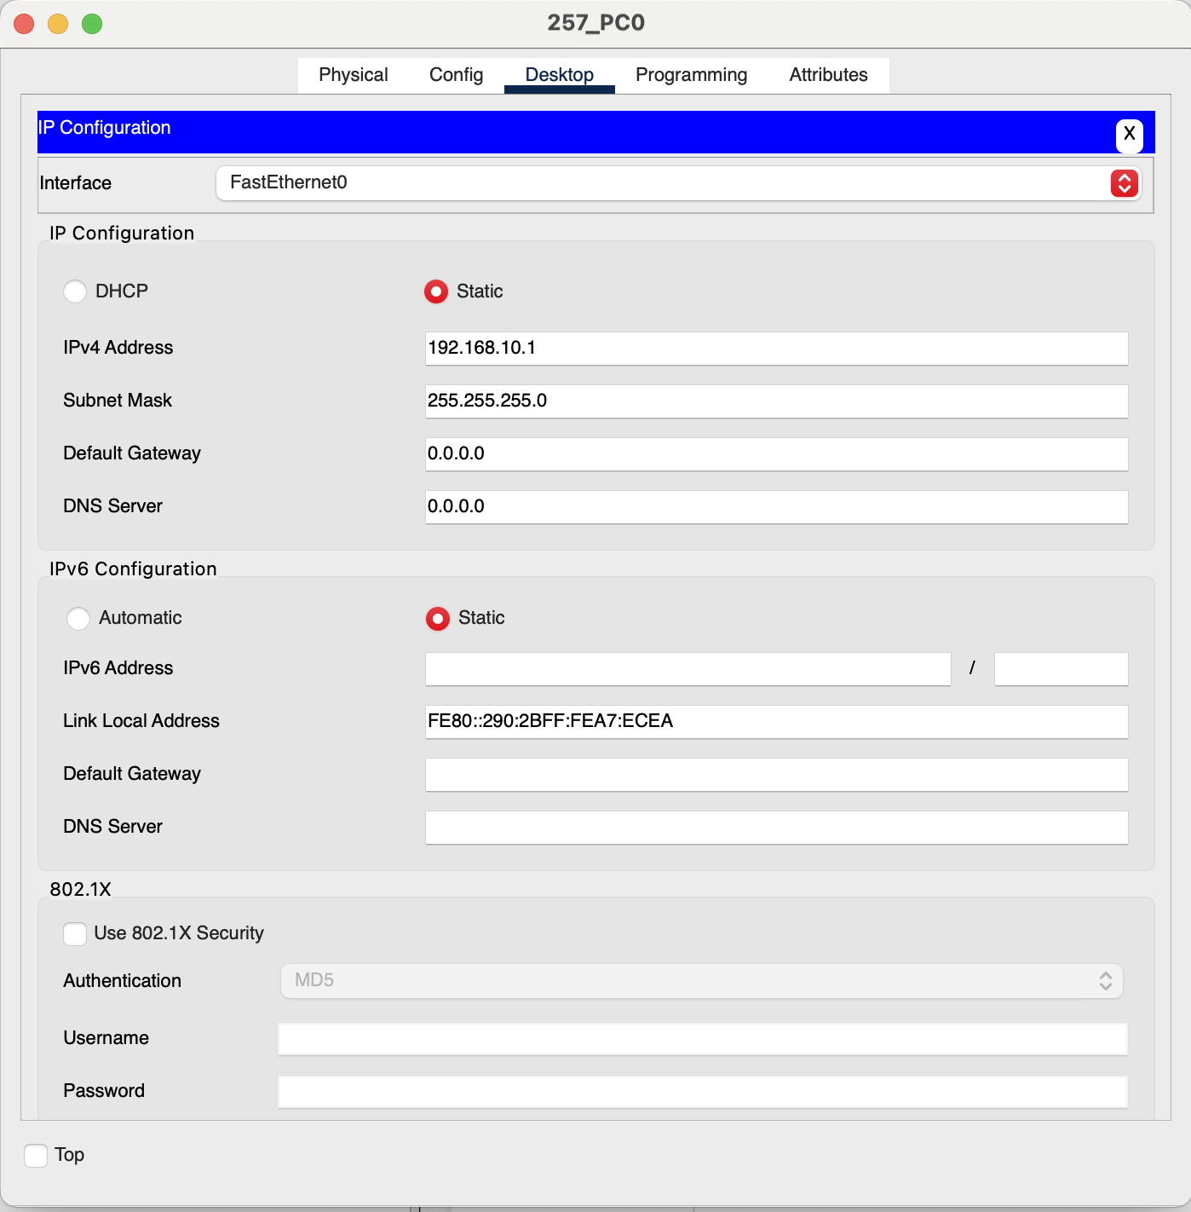

I did this for all the PCs.

**Task 04:**

Checking the status of the interfaces to make sure they are up and running:

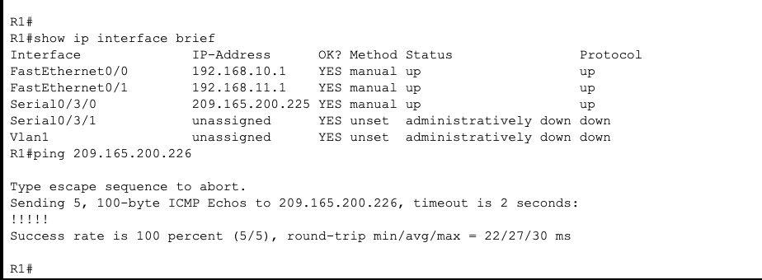

**Task 05:**

Checking if the gateway router can be reached from each PC:

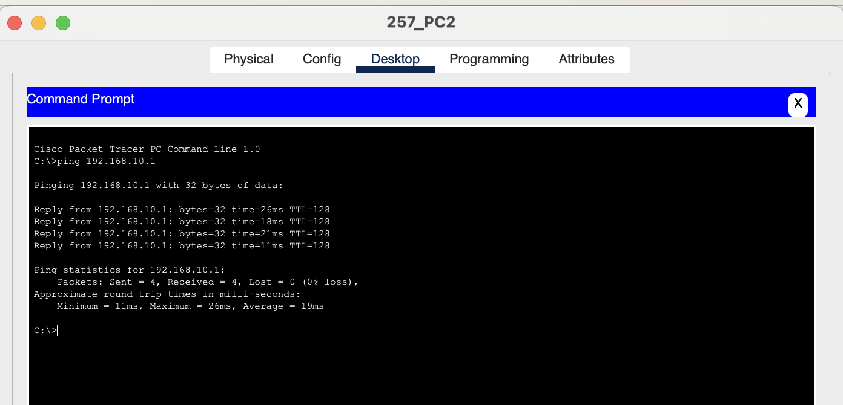

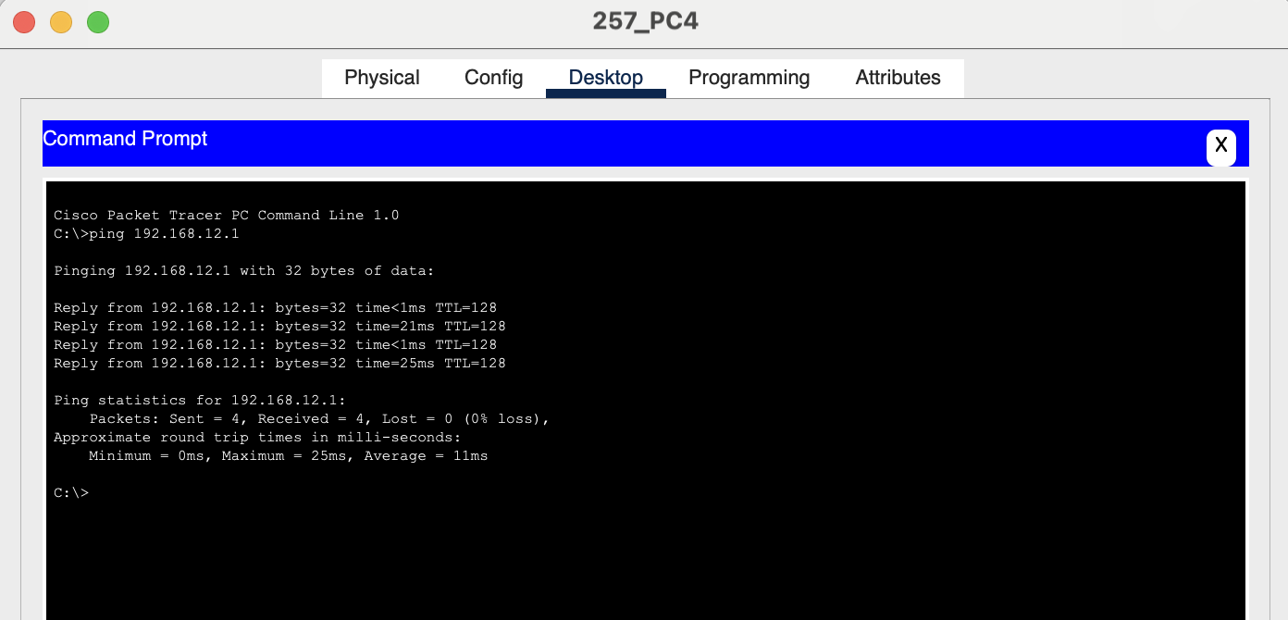

This is same for all the four PCs.

### **Questions (Answer to the point)**:

**Q1.** Write the command for adding a **motd banner** with the string "*Restricted Access. Only for authorized individuals.*"

**Ans:** *banner motd #*  
Restricted Access. Only for authorized individuals.

#

**Q2.** What is the recommended way of enabling password in a cisco device? Why it's better than other methods?

**Ans:** *enable secret* [password]

This one is better because it is the recommended way to enable password as it stores the md5 hash of the given password. You can view the password in running-config.

**Q3.** What are the differences between DCE and DTE cables?

Ans:

**Q4.** Write the command to check the status of all interfaces in a router.

Ans: *show ip interface brief*

**Q5.** How do you make all the configuration changes in a cisco device persistent? What would happen if you don’t do this?

Ans: *copy running-config startup-config*

Any changes made will be lost if the device is rebooted or powered off, if I don’t do this.

### **Challenges (if any):**

### 